PROJECT GANTT CHART
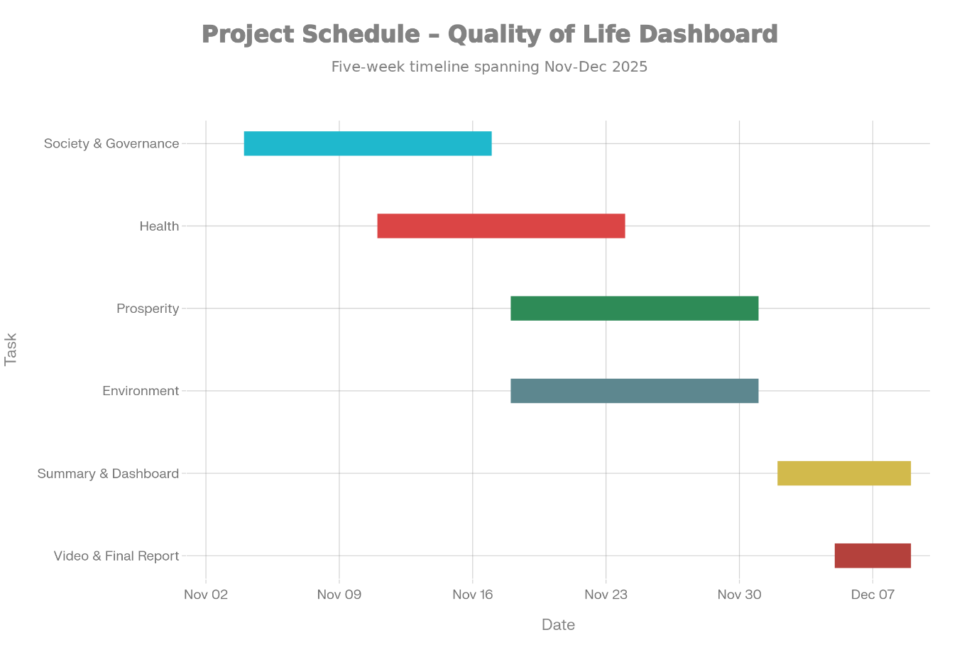
Gantt-style project timeline from early November to December 9, 2025
Phase / Page | Start date | End date | Notes
Society & Governance pages | 04-Nov-25 | 17-Nov-25 | Data collection, Power Query cleaning, DAX for KPIs, Society & Governance visuals
Health page | 11-Nov-25 | 24-Nov-25 | Parallel work: health datasets, cleaning, DAX, page design
Prosperity page | 18-Nov-25 | 01-Dec-25 | Prosperity datasets, income and labour-force modeling, visuals
Environment page | 18-Nov-25 | 01-Dec-25 | Environment datasets, GHG and air quality modeling, visuals
Summary page & overall dashboard | 02-Dec-25 | 09-Dec-25 | Composite indicators, cross-page slicers, summary visuals & final dashboard

Table of content

1. INTRODUCTION 3
2. PROJECT OVERVIEW 4
3. DATA AND PREPARATION 6
4. DATA MODEL AND DAX MEASURE 8
5. INDICATOR PAGES, DASHBOARD DESIGN AND KEY VISUALS 14
6. INSIGHTS 21
7. CHALLENGES FACED 23
8. CONCLUSION 24
9. REFERENCES 25

INTRODUCTION

Understanding the quality of life of Canadians requires a holistic view that goes beyond economic performance alone. The Government of Canada’s Quality of Life Framework (QoL Framework) provides a comprehensive structure for measuring national well-being across five interconnected domains: Prosperity, Health, Society, Good Governance, and Environment. These domains reflect not only how Canadians are doing economically, but also socially, physically, institutionally, and environmentally.
This report presents an interactive Power BI dashboard that brings the QoL Framework to life by integrating multiple datasets from Statistics Canada. Each domain is represented by key headline indicators that track national trends, highlight regional differences, and identify changes over time. By combining these indicators into a single visualization environment, the dashboard enables users to explore the factors that shape well-being in Canada from 2021 to 2024.
To complete this project, each team member was responsible for one domain of the QoL Framework. Their tasks included collecting relevant datasets, cleaning and transforming the data in Power BI, building trend analyses, and developing KPI visuals for the most recent year. The domains are then integrated into a unified Summary Page, which provides an at-a-glance overview of Canada’s most important quality-of-life trends, supported by slicers, navigation controls, and domain-specific insights.
Overall, this dashboard provides a user-friendly, data-driven tool for understanding how Canadians’ well-being has evolved over time. It allows policymakers, researchers, and the public to identify strengths, monitor emerging challenges, and better understand the interconnected factors that contribute to quality of life in Canada.

PROJECT OVERVIEW

This project aims to design and develop an interactive Power BI dashboard that visualizes key indicators from Canada’s Quality of Life Framework. The dashboard consolidates multiple datasets from Statistics Canada and presents them through clear, accessible, and domain-specific pages, along with a unified Summary Page.
The team divided responsibilities across five major domains of the framework Governance, Society, Prosperity, Environment and Health with each member preparing data, building visuals, and interpreting trends for their assigned domain. Once individual domain pages were completed, all components were merged into a single Power BI report to develop a cohesive and user-friendly visualization tool.
The Society page focuses on the four headline indicators identified in Canada’s Quality of Life Framework: strong sense of belonging to local community, having someone to count on, trust in others, and satisfaction with time use. These indicators provide a high-level view of social cohesion and connectedness in Canada, and the visuals on this page are designed for analysts who need to quickly assess levels, trends, and recent changes.
The Prosperity dimension evaluates economic well-being, financial stability, and access to resources that support a high quality of life in Canada. It captures how individuals and families experience income levels, labour force opportunities, and financial vulnerability. Strong prosperity indicators signify a healthy, equitable, and resilient economy where Canadians are able to participate fully in society.
For this project, the Prosperity analysis focuses on three core StatCan datasets:
- Labour Force Characteristics (employment, unemployment, participation)
- Market Income & Government Transfers (earnings, income composition)
- Low-Income Statistics (LIM thresholds, poverty prevalence)
These indicators collectively reflect economic opportunity, household stability, and financial security. Two groups of values market income and low-income measures serve as headline indicators within the QoL Prosperity dimension due to their importance in evaluating Canadians’ economic resilience.
All datasets were cleaned, transformed, modelled, and visualized in Power BI to highlight long-term trends, yearly changes, and provincial comparisons across prosperity-related measures.
The Health dimension of the Quality-of-Life Framework for Canada explores how Canadians perceive their overall physical and mental well-being along with the prevalence of key chronic health conditions. It focuses on the following four indicators:
- Perceived health, very good or excellent (Headline Indicator)
- Perceived mental health, very good or excellent (Headline Indicator)
- High blood pressure (%)
- Diabetes (%)
The Health dashboard outlines how these selected indicators have evolved between 2021 and 2024, by age and province, and how perceived well-being matches up against chronic disease trends. This dashboard can be used to support data-driven analysis for policymakers, students, and researchers studying public health trends in Canada.
The Governance dimension evaluates the degree of trust, fairness, and institutional effectiveness experienced by people in Canada. It focuses on how individuals perceive public institutions, media credibility, and equitable treatment within society. Strong governance contributes to stability, public confidence, and overall quality of life by ensuring that systems remain transparent, reliable, and responsive.

For this project, the Governance analysis uses four key indicators: Confidence in Institutions, Trust in Media, Cyberbullying, and Discrimination & Unfair Treatment. Among these, Confidence in Institutions and Trust in Media are identified as headline indicators, representing high-level measures of Canada’s governance performance. These datasets were prepared, modeled, and visualized in Power BI to provide clear insights into trends, comparisons, and the overall state of governance.

The Environment page focuses on two headline indicators from Canada’s Quality of Life Framework:
Air Quality and Greenhouse Gas (GHG) Emissions.
These indicators provide a high-level assessment of environmental conditions that influence overall quality of life in Canada. Air Quality reflects Canadians’ exposure to pollution, while GHG Emissions measure Canada’s contribution to climate change.
The visuals on this page are designed for policy analysts and environmental data users who need to quickly assess current levels, historical trends, and recent year-over-year changes for these environmental headline indicators.

- DATA AND PREPARATION

Data sources and alignment with QoL framework
Data for all five Quality of Life (QoL) dimensions—Society, Prosperity, Health, Governance, and Environment—were obtained from Statistics Canada, primarily through the Quality of Life (QoL) Hub and related data tables. All datasets were downloaded as CSV files using the official “Download options” in StatCan’s Data Viewer, ensuring that each indicator is consistent with Canada’s QoL framework and that multi-year time series are available where possible. Across dimensions, common structural fields include reference date (REF_DATE), geography (GEO), indicator or category fields, and the numeric value (VALUE). These common elements enabled a coherent star-schema style model in Power BI, with a shared Date table and standardized geography fields.
Society – social cohesion and trust
For the Society dimension, four headline indicators were used: sense of belonging to local community, having someone to count on when needed, most people can be trusted, and high satisfaction with time use. Data for each indicator were sourced from QoL Society tables (Table IDs 45-10-0052, 45-10-0050, 45-10-0099, and 45-10-0067), covering 2021–2024 (or 2023–2024 for trust). Each CSV contained fields such as REF_DATE, GEO, Gender, response category (Indicators), and VALUE. Metadata columns (e.g., DGUID, UOM, COORDINATE, STATUS, SYMBOL, VECTOR, SCALAR_FACTOR,
DECIMALS) were removed. Columns were then renamed to a common schema (Date, Geography,
Gender, Indicator, Value), and a custom IndicatorName column was added to tag each row with its headline indicator. Only the response category representing the headline definition (e.g., “very strong or somewhat strong sense of belonging”) was retained, so Value directly represents the QoL percentage. The four cleaned queries were appended into a single SocietyIndicators fact table with fields: Date, Geography, Gender, IndicatorName, Indicator, and Value, which drives the Society page visuals and the Society headline score.
Prosperity – labour, income, and low income
Prosperity analysis uses three main StatCan tables: labour force characteristics (Table 14-10-0287-01), market income and government transfers (Table 11-10-0190-01), and low-income statistics (LIM) (Table 11-10-0135-01). These datasets provide monthly or annual time series from the mid-1970s onward. From each CSV, only core variables were kept: REF_DATE, GEO, VALUE, and the main indicator descriptor (IndicatorType / concept field). Metadata fields such as DGUID, COORDINATE,
STATUS, SYMBOL, SCALAR_ID, UOM_ID, VECTOR, SCALAR_FACTOR, DECIMALS, and secondary concept fields were removed. Columns were renamed to align across datasets (Date, Geography,
Indicator, Value), and data types were standardized (Date as Date, Geography as Text, Value as Decimal). A combined IndicatorName column was created (e.g., concatenation of concept and type where needed) so the three sources share a consistent logical identifier. After verification, each prepared table exposed the same set of columns Date, Geography, Indicator, IndicatorName, Value—allowing labour, income, and low-income measures to be analysed together in a unified prosperity model.
Health – headline health indicators
Health data were drawn from QoL health tables, especially Table 13-10-0905-01, supplemented by additional StatCan tables for diabetes and high blood pressure prevalence. The focus was restricted to four headline measures: perceived health, perceived mental health, high blood pressure, and diabetes. In Power Query, indicators were filtered to include only these four; geographies were limited to Canada and provinces, and age groups were restricted to key categories (18–34, 35–49, 50–64, 65+, and total 18+), with both sexes combined.
Columns were standardized (REF_DATE → Date, GEO → Geography, VALUE → Percent) and converted to appropriate types, with percent values stored as decimals and formatted as percentages in the report. Non-essential metadata columns (e.g., UOM, flags, and DGUID) were removed, yielding a clean health fact table ready for age-group and time-trend analysis of the four headline health indicators.
Governance – trust, media, cyberbullying, and discrimination
Governance covers four indicators: confidence in institutions (headline), trust in media, cyberbullying, and discrimination and unfair treatment. Data for these were collected from a combination of StatCan indicators-module tables and social statistics tables, all at annual frequency. Each dataset originally included REF_DATE, GEO, indicator/characteristic fields, VALUE, Gender, and numerous metadata columns. Using Power Query, only REF_DATE, GEO, Indicators, VALUE, and Gender were retained; remaining columns (e.g., DGUID, UOM, VECTOR, STATUS, SYMBOL, SCALAR_ID) were removed. Fields were renamed to a common structure (Date, Geography, Indicator, Value, Gender), and a dataset-specific IndicatorName column was added with fixed values (“Confidence in Institutions”, “Trust in Media”, “Cyberbullying”, “Discrimination & Unfair Treatment”). After verifying that each table contained exactly Date, Geography, Value, IndicatorName, and Gender, the four queries were appended into a single Fact_Governance table, which serves as the core source for the Governance page and related summary metrics.
Environment – air quality and greenhouse gas emissions
Environment data were taken from QoL environmental tables for national Air Quality and Greenhouse Gas (GHG) emissions. After importing CSVs into Power BI, cleaning focused on retaining only essential columns: Date (or reference year), Geography, the specific indicator category, a numeric Value, and a custom IndicatorName flag (e.g., “Air Quality” or “Greenhouse Gas Emission”). Non-Canadian regions were filtered out, Year fields were standardized, and column names were aligned across the two datasets. The cleaned tables were then appended into a single EnvironmentIndicator fact table, providing a consistent structure for comparing trends in air quality and GHG emissions over time and supporting both dimension-level and summary-page visuals.
Shared modelling and DAX
All fact tables (SocietyIndicators, Prosperity, Health_Indicators, Fact_Governance, EnvironmentIndicator) share a common Date field that is linked to a central DimDate table, enabling report-wide Year filtering from the summary page. Geography fields are also aligned where possible to allow consistent Canada-level and provincial views. With this standardized model, DAX measures such as Latest Value, Previous Year Value, Year Change, Year Change %, and composite headline scores were defined per dimension, feeding both the individual dimension pages and the overall analytical dashboard.

4. DATA MODEL AND DAX MEASURE
Society
The data model for this page consists of the Society Indicators table related to the report Date hierarchy, with common fields (Date, Geography, Indicator Name, Response, Value) standardized across sources. Building on this model, several DAX measures were created, including Latest Value (latest available value per indicator), Previous Year Value, Year Change, Year Change %, and a Headline Score measure that averages the latest values of the four headline indicators to summarize overall Society performance. These measures drive the KPI cards and change overtime analysis and will be included in the DAX appendix of the report.​

“Latest value” measure
Latest Value :=
VAR LatestDate =
MAX ( SocietyIndicators[Date] )
RETURN
CALCULATE (
SUM ( SocietyIndicators[Value] ),
SocietyIndicators[Date] = LatestDate
)

Previous year” and “Year change” measure
Previous Year Value :=
VAR LatestYear =
YEAR ( MAX ( SocietyIndicators[Date] ) )
VAR PrevYear =
LatestYear - 1
RETURN
CALCULATE (
SUM ( SocietyIndicators[Value] ),
YEAR ( SocietyIndicators[Date] ) = PrevYear
)

Year Change :=
[Latest Value] - [Previous Year Value]

Year Change % :=
DIVIDE ( [Year Change], [Previous Year Value] )

Society “headline score”
Headline Score :=
AVERAGEX (
VALUES ( SocietyIndicators[IndicatorName] ),
IF (
SocietyIndicators[IndicatorName] IN {
"Sense of belonging to local community",
"Someone to count on",
"Trust in others",
"Satisfaction with time use"
},
[Latest Value]
) )

Prosperity

Year Average
3Y Average =
AVERAGEX(
VALUES('ProsperityIndicator'[Date]),
CALCULATE(SUM(ProsperityIndicator[Value]))
)

Market Income Latest Value
Market Income Latest Value =
VAR MaxYear = MAX('ProsperityIndicator'[Date])
RETURN
CALCULATE(
SUM(ProsperityIndicator[Value]),
'ProsperityIndicator'[Date] = MaxYear
)

Market Income Previous Year Value
Market Income Previous Year Value =
VAR MaxYear = MAX(ProsperityIndicator[Date]) - 1
RETURN
CALCULATE(
SUM(ProsperityIndicator[Value]),
ProsperityIndicator[Date] = MaxYear
)

Low Income 3Y Average
Low Income 3Y Average =
AVERAGEX(
VALUES('ProsperityIndicator'[Date]),
CALCULATE(SUM(ProsperityIndicator[Value]))
)

Low Income Latest Value
Low Income Latest Value =
VAR MaxYear = MAX('ProsperityIndicator'[Date])
RETURN
CALCULATE(
SUM(ProsperityIndicator[Value]),
'ProsperityIndicator'[Date] = MaxYear
)

Low Income Previous Year Value
Low Income Previous Year Value =
VAR MaxYear = MAX(ProsperityIndicator[Date]) - 1
RETURN
CALCULATE(
SUM(ProsperityIndicator[Value]),
ProsperityIndicator[Date] = MaxYear
)

Labour Force Latest Value
Labour Force Latest Value =
VAR MaxYear = MAX('ProsperityIndicator'[Date])
RETURN
CALCULATE(
SUM('ProsperityIndicator'[Value]),
'ProsperityIndicator'[Date] = MaxYear
)

Labour Force Previous Year Value
Labour Force Previous Year Value =
VAR MaxYear = MAX(ProsperityIndicator[Date]) - 1
RETURN
CALCULATE(
SUM('ProsperityIndicator'[Value]),
'ProsperityIndicator'[Date] = MaxYear
)

Labour Force 3Y Average
LabourForce3Y_Average =
AVERAGEX(
VALUES('ProsperityIndicator'[Date]),
CALCULATE(SUM('ProsperityIndicator'[Value]))
)

Health
The data model uses a single fact table: Health_Indicators.
Included fields:
  - Year
  - Geography
  - Age group
  - Indicator
  - Percent
A date table was not required because the dataset is already aggregated annually.

Key DAX Measures
Base Indicator Measures
Example:
Perceived Health % :=
CALCULATE(
AVERAGE(Health_Indicators[Percent]),
Health_Indicators[Indicator] = "Perceived health, very good or excellent"
)

Similar measures were created for mental health, diabetes, and high blood pressure.

Latest Value Measures
Example:
Latest Perceived Health % :=
VAR LatestYr = CALCULATE(MAX(Health_Indicators[Year]), ALL(Health_Indicators))
RETURN CALCULATE([Perceived Health %], Health_Indicators[Year] = LatestYr)

Year-over-Year Change
Example:
Perceived Health YoY Change :=
VAR CurrentYear = MAX(Health_Indicators[Year])
VAR PrevYear = CurrentYear - 1
VAR CurrentValue = CALCULATE([Perceived Health %], Health_Indicators[Year] = CurrentYear)
VAR PreviousValue = CALCULATE([Perceived Health %], Health_Indicators[Year] = PrevYear)
RETURN CurrentValue – PreviousValue
4. Dashboard Design and Key Visuals

Governance
To enable accurate time-series analysis and create interactive visuals, additional modeling steps were performed.
Date Table
A separate Date table was created using DAX:
Date = CALENDAR(MIN(Fact_Governance[Date]), MAX(Fact_Governance[Date]))
Additional columns such as Year, Month, and Quarter were added.
Dim_Indicator Table
A manual dimension table was created:
IndicatorName | IsHeadline | HigherIsBetter
Confidence in Institutions | TRUE | TRUE
Trust in Media | TRUE | TRUE
Cyberbullying | TRUE | TRUE
Discrimination & Unfair Treatment | TRUE | TRUE
This table allowed scoring models and composite headline indicators.
Relationship Setup
Relationships created:
- Fact_Governance[Date] → Date[Date]
- Fact_Governance[IndicatorName] → Dim_Indicator[IndicatorName]
DAX Measures
Latest Value
Latest Value =
VAR MaxDate = CALCULATE(MAX(Fact_Governance[Date]), ALLSELECTED(Fact_Governance))
RETURN CALCULATE(SUM(Fact_Governance[Value]), Fact_Governance[Date] = MaxDate)

Previous Year
Previous Year Value =
VAR LatestYear =
YEAR ( MAX ( Fact_Governance[Date] ) )
VAR PrevYear =
LatestYear - 1
RETURN
CALCULATE (
SUM ( Fact_Governance[Value] ),
YEAR ( Fact_Governance[Date] ) = PrevYear
)

Year Change
Year Change =
[Latest Value] - [Previous Year Value]

Year Change %
Year Change % =
DIVIDE ( [Year Change], [Previous Year Value] )

YoY % Change
YoY % Change =
VAR CurrentValue = [Latest Value]
VAR PrevValue = CALCULATE([Latest Value], DATEADD('Date'[Date], -1, YEAR))
RETURN DIVIDE(CurrentValue - PrevValue, PrevValue)

3-Year Moving Average
Moving Average 3Y =
AVERAGEX(
DATESINPERIOD('Date'[Date], MAX('Date'[Date]), -3, YEAR),
CALCULATE(SUM(Fact_Governance[Value]))
)

Normalized Score (0–100)
Normalized Score =
VAR MinV = CALCULATE(MIN(Fact_Governance[Value]), ALL(Fact_Governance))
VAR MaxV = CALCULATE(MAX(Fact_Governance[Value]), ALL(Fact_Governance))
RETURN
IF(SELECTEDVALUE(Dim_Indicator[HigherIsBetter]),
100 * DIVIDE(SUM(Fact_Governance[Value]) - MinV, MaxV - MinV),
100 * DIVIDE(MaxV - SUM(Fact_Governance[Value]), MaxV - MinV)
)

Headline Composite Score
Headline Composite =
AVERAGEX(
FILTER(Dim_Indicator, Dim_Indicator[IsHeadline] = TRUE),
CALCULATE([Normalized Score])
)

Environment
Data Model and DAX Measures
The data model consists of:
- A single fact table EnvironmentIndicator, containing Year, Geography, Sector (when applicable), NameIndicator, and Value.
- A connected Date table to support year-based calculations.
- A shared IndicatorName field to easily compare both headline indicators in the same visuals.
Latest Value
Env Latest Value :=
VAR LatestYear =
MAX ( EnvironmentIndicator[Year] )
RETURN
CALCULATE (
SUM ( EnvironmentIndicator[Value] ),
EnvironmentIndicator[Year] = LatestYear
)
Previous Year Value
Env Previous Year Value :=
VAR LatestYear =
MAX ( EnvironmentIndicator[Year] )
VAR PrevYear =
LatestYear - 1
RETURN
CALCULATE (
SUM ( EnvironmentIndicator[Value] ),
EnvironmentIndicator[Year] = PrevYear
)
Year Change
Env YoY Change :=
[Env Latest Value] - [Env Previous Year Value]
Year Change %
Env YoY % :=
DIVIDE ( [Env YoY Change], [Env Previous Year Value] )
A separate DAX measure was created for each indicator (Air Quality and GHG) to support KPI visuals—mirroring the specific indicator DAX shown in the Society example.

5. INDICATOR PAGES, DASHBOARD DESIGN AND KEY VISUALS
Society
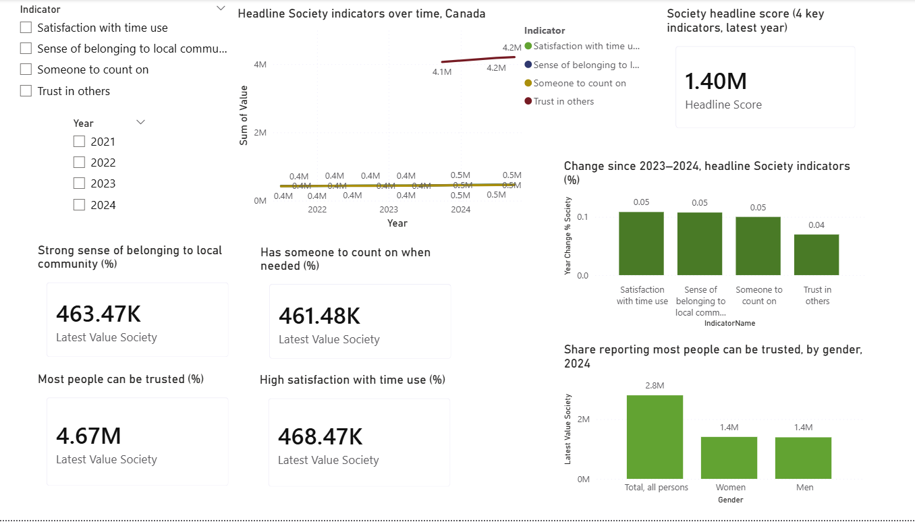
At the top of the page, Year and Indicator slicers allow users to filter the view, while a multi-series line chart (“Headline Society indicators over time, Canada”) shows the evolution of all four headline indicators from 2021 to 2024. A large KPI card on the right displays the Society headline score, providing a single, easy to interpret measure for the latest year. The middle row contains four KPI cards, one for each indicator, showing the latest national values; this layout makes it easy to compare the current levels of belonging, social support, trust, and satisfaction with time use side by side. At the bottom, a column chart presents the percentage change from 2023 to 2024 for each headline indicator (Year Change %), highlighting which dimensions have improved the most in the most recent period, while a second chart breaks down “most people can be trusted” by gender, allowing a quick comparison of trust levels between women, men, and the total population.​

Prosperity
Design & Visuals (Prosperity Dashboard Page)
Your Prosperity page includes three primary visual sections.

Key Performance Indicators
- Market Income — Latest Value
- Market Income YoY Change
- Low Income — Latest Value
- Low Income YoY Change
- Labour Force — Latest Value
- Labour Force YoY Change
These provide instant insight into national-level prosperity conditions.

Trend Line Chart
A multi-series line chart showing long-term trends:
- Median Market Income
- Low-Income Median Value
- Employment Rate / Labour Force Participation Rate
These highlight how labour opportunities and income conditions evolve over time.

Comparison & Details
- Bar chart displaying average indicator values by IndicatorType
- Table with gender breakdown for labour indicators
- Summary bar chart for income categories

Includes columns
- Indicator Name
- Region
- Gender
- Latest Value
- YoY % Change
- Normalized Score

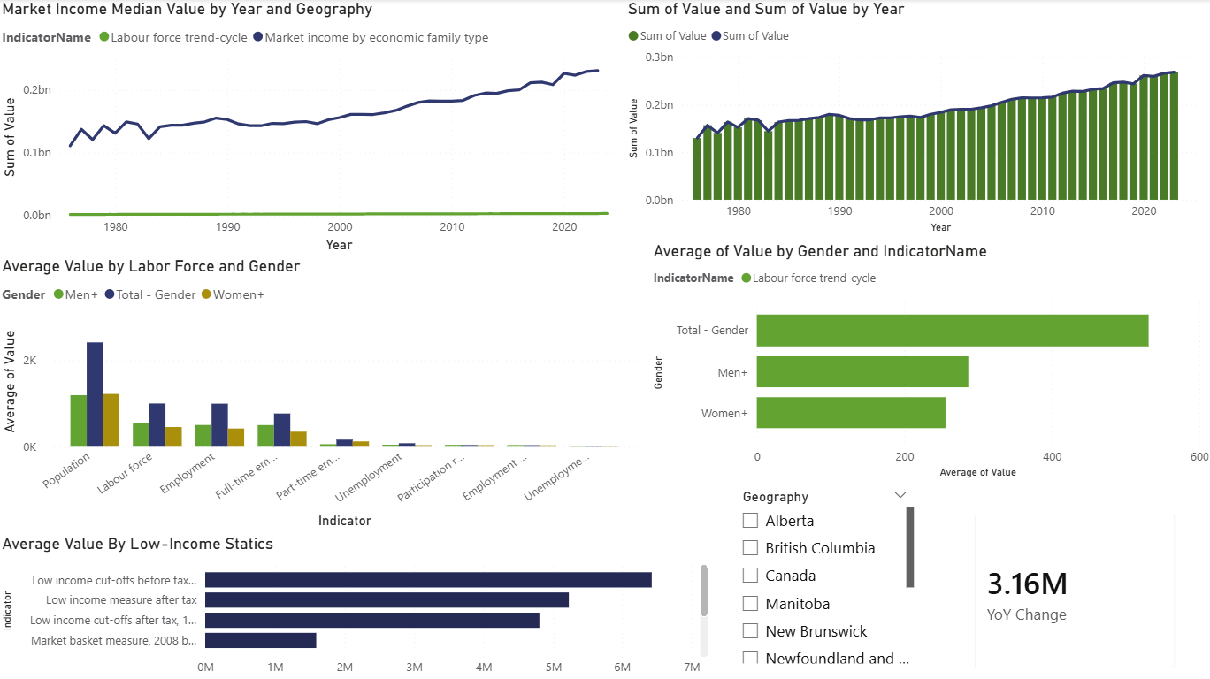
Health
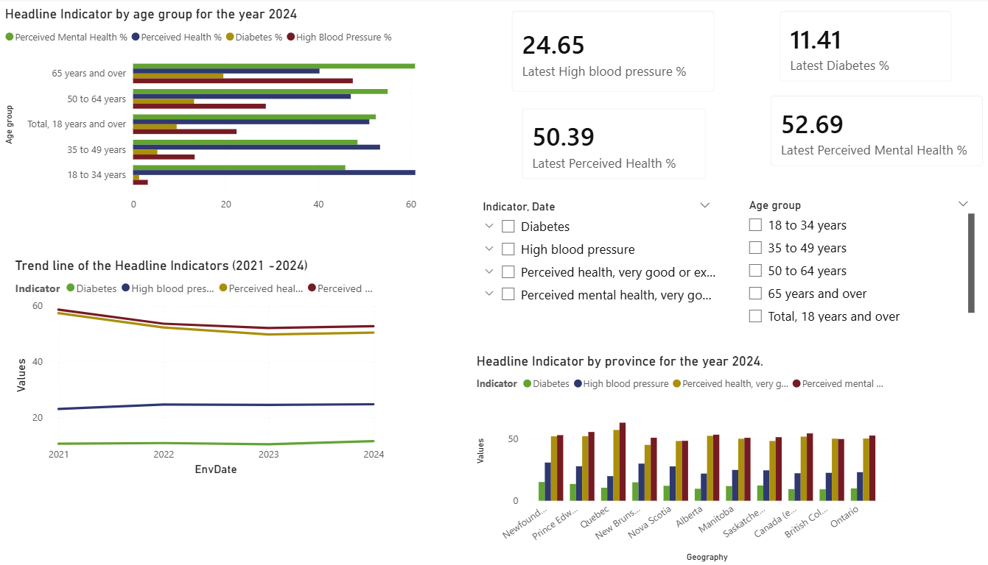
The Health dashboard was constructed to be clear, easy to interpret, and in line with QoL framework priorities.
Four KPI cards show the latest values, namely Latest Perceived Health %, Latest Perceived Mental Health %, Latest High Blood Pressure %, and Latest Diabetes %. We have put headline indicators at the very top to emphasize its importance. A multi-line chart compares trends over time for the four headlines. It enables our audience to see at one look, declines in perceived health and mental health, and Gradual rises in Diabetes and High Blood Pressure. Next we have a clustered column chart comparing the values of the indicators across province. This presents geographic disparities and gives an idea of regional public health variations. We also attached a Age Group Breakdown (2024) - a horizontal bar chart displays the indicator values across age groups. This visualization conveys vividly the rising chronic disease rates with increasing age, as well as the higher ratings by younger adults on mental health. Slicers allow users to filter by:
  - Indicator
  - Year
  - Age group
These slicers make the dashboard fully interactive and analytical.

Governance
Design & Visuals (Governance Dashboard Page)
The Governance dashboard includes:
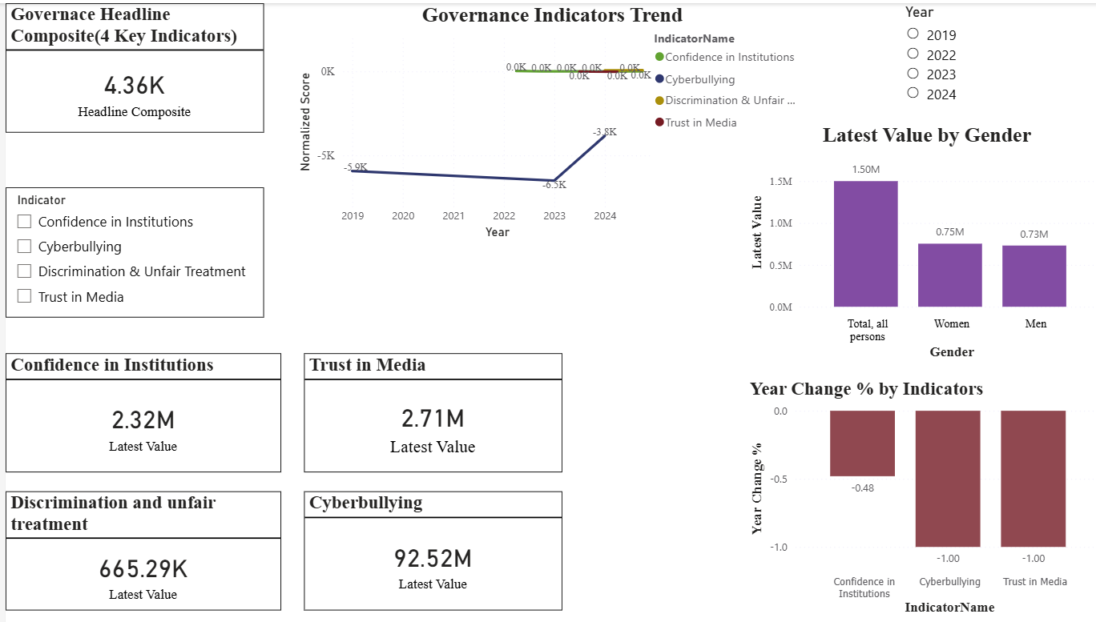
Top Row - Key Performance Indicators
- Headline Composite Score
- Confidence in Institutions (Latest Value)
- Trust in Media (Latest Value)
- Discrimination and unfair treatment (Latest Value)
- Cyberbullying (Latest Value)
These emphasize Canada’s two governance headline indicators.
Middle Section - Trend Line Chart
A multi-series line chart displaying changes over time for all four indicators:
- Confidence in Institutions
- Trust in Media
- Cyberbullying
- Discrimination & Unfair Treatment
This visual shows overall societal trends, increases, declines, and stability.
Bottom Section - Comparison & Details
- Bar Chart - Latest year comparison across all four indicators
- Table - Detailed values including:
- Indicator Name
- Gender
- Latest Value
- YoY % Change
- Normalized Score (0–100)
- Status highlighting via colour formatting
Slicers
- Year
- Indicator
These allow interactive exploration by users.

Environment
Dashboard Design and Key Visuals
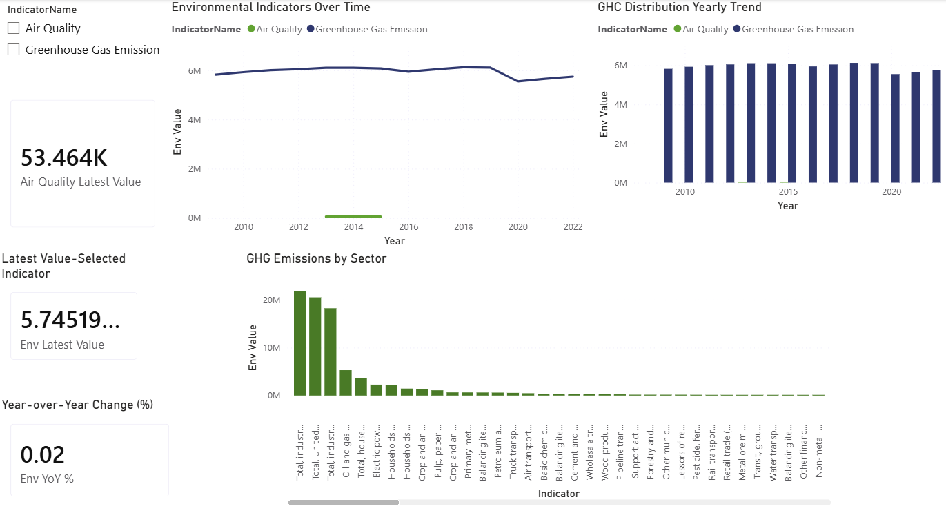
Top of Page
- Indicator slicer and Geography slicer allow analysts to switch between Air Quality and GHG emissions at the national or sub-national level.
- A multi-series line chart shows long-term environmental trends.
- GHG emissions typically appear as multiple sectors (e.g., transportation, oil & gas).
- Air Quality appears as a national time series of PM2.5 levels.

Middle Row
This row contains KPI cards for each indicator:
- Air Quality – Latest Value
- GHG Emissions – Latest Value
- GHG Emissions – Year Change %

Bottom Section
- Column chart – Year Change %
- Shows which environmental indicator has improved or worsened most in the most recent year.
- Air Quality improving = lower PM2.5 exposure.
- GHG emissions improving = lower total emissions.

- Sector breakdown chart (for GHG)
- Displays emissions by sector for the selected year, helping analysts understand what is driving change.

Summary - Dashboard
The Quality of Life – Summary Overview Dashboard provides an integrated, high-level view of Canada’s performance across multiple wellbeing dimensions, including Society, Health, Governance, Prosperity, and Environment. It consolidates key indicators from each domain to help users quickly assess overall trends, recent changes, and geographic patterns.
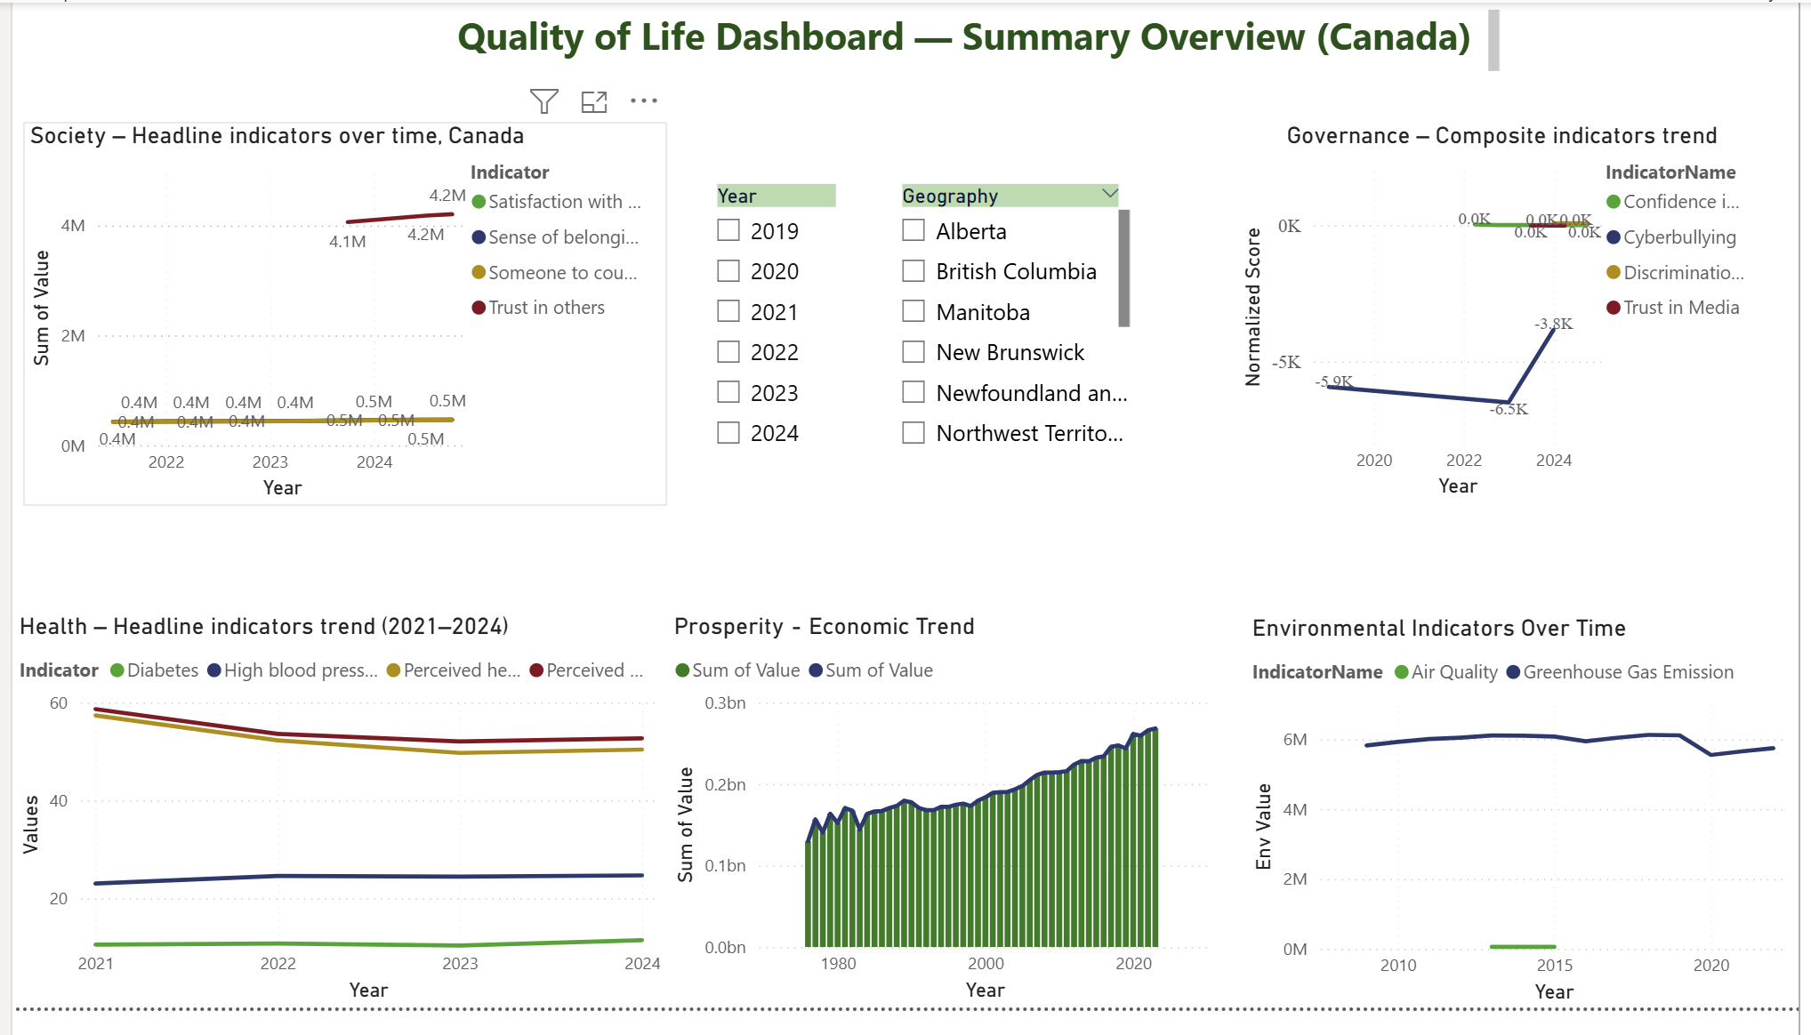
The dashboard brings together multiple visualizations into one unified page:
- Society Indicators Over Time: A multi-year line chart highlighting trends in social wellbeing measures such as belonging, trust, time-use satisfaction, and social support.
- Governance Composite Trend: A comparison of institutional trust, media trust, cyberbullying, and discrimination indicators over recent years.
- Health Indicators Trend: A four-indicator line chart showing long-term performance in diabetes, high blood pressure, perceived health, and perceived mental health.
- Prosperity Trend: A long-term economic series showing changes in prosperity-related values across several decades.
- Environment Indicators: Line charts representing air quality and greenhouse gas emissions over time.
These visuals work together to give a holistic picture of quality of life at the national level.
Data Modeling Enhancements
To support interactive filtering and ensure consistent time and geography analysis across all domains, two-dimension tables were created and integrated into the model:
- DimDate Table
A full date dimension was added to allow proper time-based filtering.
Some datasets originally contained only a Year field rather than full dates. To fix this:
A new column EnvDate was created in:
- Health Indicator table
- Environment Indicator table
This derived date field enabled accurate linking to DimDate, ensuring all time-based visuals respond correctly to the Year slicer.
- DimGeography Table
A standardized geography table was created and connected to:
- Health
- Society
- Governance
- Environment
- Prosperity
This supports a single Geography slicer on the Summary page that filters all visuals simultaneously.
Relationships and Model Structure
Using Manage Relationships, all fact tables (Health, Society, Governance, Prosperity, Environment) were connected to:
- DimDate (one-to-many)
- DimGeography (one-to-many)
This star-schema structure ensures consistent filtering across all domains and enables seamless interactions between slicers and visuals.
Overall Impact
The completed Summary Dashboard provides:
- A unified view of Canada’s wellbeing across multiple dimensions
- Interactive analysis through synced Year and Geography slicers
- Standardized relationships enabling clean and accurate cross-filtering
- Improved data modeling through DimDate, DimGeography, and corrected date fields
- This page acts as a concise executive overview, allowing users to explore national-level quality-of-life trends in one place.
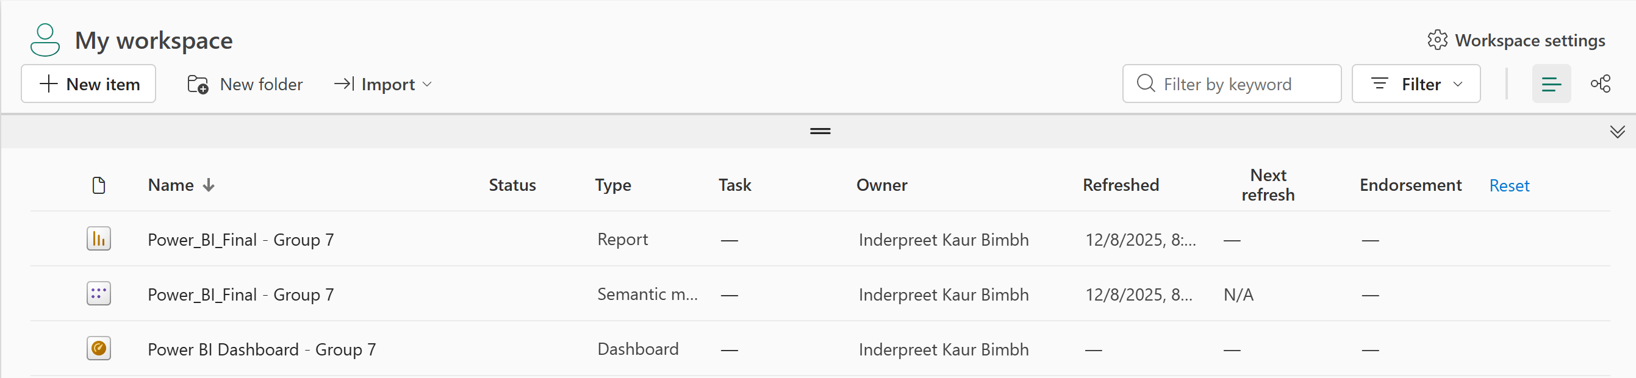Once the dashboard was finalized, it was published to the Power BI Service to make it accessible online for all team members and viewers. Publishing the service allows the report to be viewed, shared, and interacted directly through a web browser, without requiring Power BI Desktop. It also ensures that the slicers, visuals, and relationships function consistently across devices. By hosting the dashboard in the Power BI Service, we enabled easy collaboration, seamless updates, and a professional presentation of the final project.
Dashboard Page (Power BI Service):
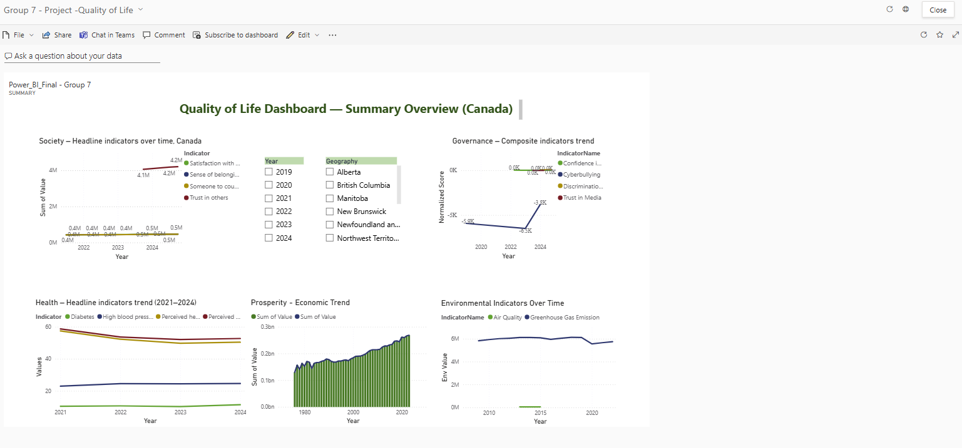

6. INSIGHTS
Society
The latest data indicate that all four Society headline indicators have increased from 2023 to 2024, with particularly strong gains in satisfaction with time use and sense of belonging to local community, as shown by the Year Change % chart and the line trends. The gender breakdown for trust in others suggests that overall trust is relatively high but remains somewhat higher for the total population compared with women and men individually, signalling potential differences in how groups experience social cohesion. Together, the Society page provides a concise but rich view of social wellbeing in Canada, supporting evidence based discussions on where social policy might further strengthen belonging, support networks and trust.

Prosperity
Here are the key findings drawn from the dashboard:
- Median Market Income has steadily increased over several decades.
Despite year-to-year fluctuations, long-term income trends show consistent upward growth.

- Low-Income measures indicate persistent vulnerability.
Although income has risen, low-income measures remain elevated in specific provinces and demographic groups.

- Labour Force participation shows cyclical behaviour.
Economic events (recessions, crises) produce visible dips, followed by recovery trends.

- Provincial disparities are significant.
Income and employment indicators vary widely between regions, reflecting uneven economic opportunity.

- Headline Composite Score reveals overall economic health.
Combining Market Income and Low-Income indicators helps track national prosperity more holistically.

Governance
- Confidence in Institutions shows year-to-year fluctuations.
There are visible changes in public trust over the years, reflecting changing political or social conditions.
- Trust in Media remains a critical governance indicator.
Media trust plays a major role in public perception and political stability. The values and trends highlight how confidence changes across time.
- Cyberbullying levels indicate public exposure to harmful online behaviour.
Although not a headline indicator, cyberbullying reflects governance challenges related to digital safety and regulation.
- Discrimination & Unfair Treatment reveals ongoing societal inequities.
This measure informs policymakers about fairness and accessibility issues across different groups.
- Combining headline indicators gives a broader governance health score.
Using the Headline Composite Score, we can see an overall view of governance perception trends in Canada.

Environment
- Air Quality:
Recent data often show small but steady improvements in PM2.5 levels across Canada. This reflects changes in transportation emissions, wildfire conditions, and industrial activity. When the YoY% card shows a decrease, it indicates better air quality.
- Greenhouse Gas Emissions:
GHG emissions tend to vary by sector. Transportation and oil & gas typically account for the largest shares. Recent trends may show slight reductions driven by cleaner technologies and policy actions; however, increases in specific sectors can offset national progress.
- Comparing the Indicators:
When viewed together, these indicators provide a high-level understanding of Canada’s environmental sustainability.
  - If Air Quality improves but GHG emissions rise, it suggests short-term pollution reductions but long-term climate risks.
  - If both indicators show improvement, this points to broader environmental gains.

Health
Based on the Health Dashboard visuals, a number of useful insights emerge.

- Decline in Perceived Health and Mental Health, 2021–2023: The headline indicators fell back over the period from 2021- 2023, with only a slight recovery in 2024. This might relate either to pandemic-related stressors or more general well-being changes.
- Gradual Increase in Chronic Conditions: Diabetes and high blood pressure show slight increases, reflecting an ageing population.
- Strong age-based differences: The rates for high blood pressure and diabetes are significantly higher among older adults, 65+. Younger adults report higher perceived mental health.
- Geographic Variation Across Provinces: Certain provinces have a higher chronic disease rate or lower perceived health, and this needs targeted health policy interventions.
- The Persistent Gap Between Mental and Physical Health: Perceived mental health has continued to lag behind perceived physical health, showing that mental health challenges persist nationally.

7. CHALLENGES FACED

Developing the Quality-of-Life Power BI dashboard involved several technical and analytical challenges. First, connecting to and downloading multiple large tables from Statistics Canada required careful selection of the correct product IDs and table structures so that each indicator aligned with Canada’s QoL framework. Second, the raw CSV files contained extensive metadata (such as flags, units, and vector codes) and inconsistent column names; cleaning and standardizing these across more than a dozen datasets in Power Query was time-consuming and required repeated iterations to ensure that fields like Date, Geography, Indicator, and Value were consistent. Third, joining indicators from different subject areas (Society, Prosperity, Health, Governance, and Environment) into a coherent data model required constructing shared dimension tables, particularly a unified Date table and standardized geography fields, and validating relationships so slicers behaved correctly across all pages.
On the visualization side, designing six coordinated report pages plus a summary overview was challenging because each dimension had different time ranges, units, and levels of detail. The team had to experiment with chart types, layout, and color palettes to avoid clutter and ensure that the most important trends and comparisons were obvious to an analyst. Implementing an analytical dashboard in the Power BI Service introduced additional considerations, such as deciding which visuals to pin, how to arrange tiles, and how to preserve interactivity with live pages. Finally, interpreting the indicators in an integrated way—so that trends in health, society, environment, governance, and prosperity could be compared meaningfully—required several review cycles and discussions within the group to align on common terminology, headline scores, and narrative insights.

8. CONCLUSION

The completed Power BI dashboard provides a comprehensive and visually engaging view of Canada’s Quality of Life indicators across the Governance, Society, and Health domains. By integrating multiple datasets from Statistics Canada into one unified reporting environment, the project successfully transforms complex data into accessible insights that support informed decision-making.

Each domain page highlights meaningful trends, geographic variations, and annual changes, giving users the ability to explore well-being from multiple perspectives. The Summary Page further strengthens the dashboard by consolidating key indicators across domains, offering a high-level snapshot that helps users quickly understand the overall direction of Canada’s quality of life.

Through collaborative teamwork, thoughtful data preparation, and effective visualization design, this project demonstrates the value of data analytics in monitoring societal progress. The dashboard serves as a practical tool for policymakers, analysts, and citizens who want to examine how different aspects of life health status, social support, institutional trust, and more interact to shape overall well-being.

As a whole, the project underscores the importance of clear communication, accurate data interpretation, and cross-domain integration in building meaningful analytical solutions. With future enhancements, such as additional domains, predictive analytics, or deeper demographic filtering, the dashboard can continue to evolve into an even more powerful resource for understanding Canada’s changing societal landscape.

9. REFERENCES

- Government of Canada, Statistics Canada. Quality of Life Hub (Canada’s Quality of Life Framework and indicator descriptions). Available from: Canada's Quality of Life Hub
- Government of Canada, Statistics Canada. Data tables – Quality of Life indicators for Canada (CSV downloads; tables 45-10-0052-01, 45-10-0050-01, 45-10-0067-01, 14-10-0287-01, 11-10-0190-01, 11-10-0135-01, 13-10-0905-01, and related QoL tables). Retrieved from the Statistics Canada Data Viewer and Quality of Life Hub.
- Iteration Insights. (n.d.). Using Statistics Canada Data in Power BI. Retrieved from https://iterationinsights.com/article/how-to-use-statistics-canada-data-in-power-bi/
- Microsoft. (n.d.). Power BI documentation (data modeling, DAX, report design, and dashboards). Retrieved from https://learn.microsoft.com/power-bi/
- Government of Canada, Statistics Canada. Web Data Service (WDS) User Guide. Retrieved from https://www.statcan.gc.ca/en/developers/wds/user-guide

